Name | KADAVA FAIZAN AHMED
Class | 7 A1

Purpose:
"Skill Assessment Program - Building Strengths Beyond Academics "
This report shows your child's interests and abilities in different school activities. With your (parents) support and our guidance, these strengths can grow into useful life skills. It helps parents notice early signs of talent and areas where extra care or practice can make a big difference.

Key Insights:
The graph below shows how your child is doing in different areas. It tells us what they like more and where we can help them do even better. Blue represents your child, and red represents the class average.
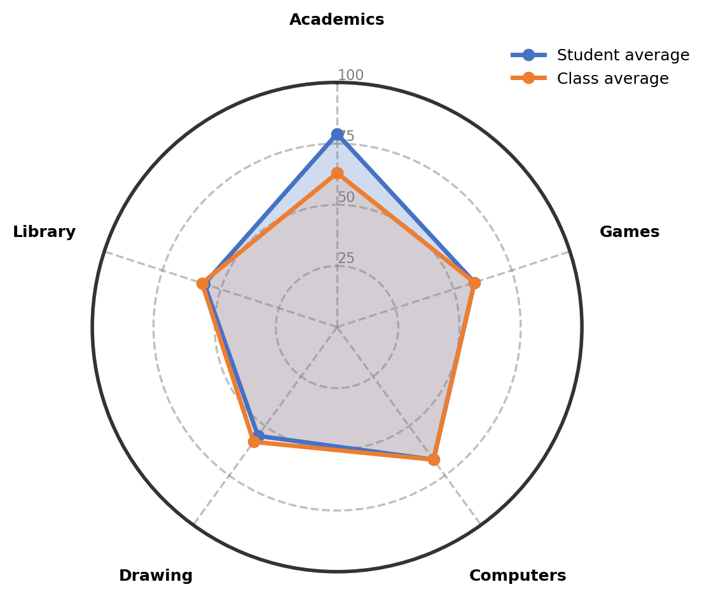

Observations:
The table gives an overview of child's involvement and performance across co-curricular areas.
Interest Area | Engagement (%) | Interest Level | Key Observations
Academics | 79% | Well-Developed Interest | Shows strong interest and good performance in English and Social subjects. The engagement is consistent and well-developed.
Computers | 67% | Positive and Active Engagement | Demonstrates active interest in computers with basic skills in drawing and typing. Shows good performance but needs consistent motivation and practice to improve further.
Games | 59% | Progressing With Guidance | Enjoys playing shuttle, kho-kho, and short cricket. Shows interest but benefits from more structured guidance to develop purposeful play.
Library | 57% | Building Confidence Gradually | Shows good interest in reading, especially story books. Building confidence gradually and needs to improve reading ability with continued practice.
Drawing | 55% | Developing Engagement | Participation is developing but shows some inconsistency. The engagement is neutral and needs nurturing to become more regular.

Recommendations & Growth Opportunities:
Here are some ways to turn your child's interests into long-term strengths:
Strong Interest Area | Potential Careers | Simple Activities to Support
Computers  (67%) | This positive engagement with computers opens doors to technology-related fields. Exploring software development, graphic design, data entry, or digital content creation is possible. Building strong computer skills now supports many future career options. | Enroll in a structured computer basics course at a local institute to strengthen typing speed and basic software skills
Library  (57%) | This growing interest in reading and books connects to communication and knowledge fields. Exploring content writing, editing, research assistance, or library science is possible. Strong reading skills form the foundation for many academic and professional paths. | Join a children's book club at the local library or community center to improve reading comprehension and discussion skills

How Parents Can Help:
1. Weekend Exploration (Computers): Dedicate a Saturday morning to a fun online tutorial that teaches basic graphic design or document formatting, connecting it to the interest in drawing and typing.
2. Short Daily Practice (Library): Encourage 15 minutes of reading aloud from a favorite story book each evening to improve reading fluency and expression.
3. Encourage and Talk: Dedicate 10-15 minutes weekly to discuss what your child enjoys about computer activities and reading, and appreciate their efforts in these areas.

Conclusion:
Your child shows wonderful natural strengths in computers and reading, with good academic performance in language and social subjects. At this stage, steady growth and exploration are most important. The interests developing now provide a strong foundation for many future possibilities. Continue supporting this natural curiosity with practical, low-pressure activities that build confidence and skills gradually.

Notes:
Parents remarks:
Teachers' remarks:

